**Waves and Optics Experimental**

**Physical Chemistry II Lab**

**CHM4111L**

**Dr. Clark**

**1. Relation to Lecture**

Wave mechanics is the language of quantum mechanics, extended to objects that we don’t classically think of as “wave-like”. In CHM4411, we use principles central to wave mechanics, like a wave’s wavelength, frequency, and amplitude, as well as concepts like wave interference and boundary conditions, in order to think about objects. In chemistry, our objects of interest, like electrons and protons, are small enough to where they are governed by the principles of quantum mechanics, where an intuition in wave mechanics becomes increasingly useful. Mastering the math of wave mechanics on “classical” waves will give you a leg up on the math and intuition behind quantum waves that underlie all chemical reactivity.

**2. Introduction**

Part I Optics Measuring the Speed of Light Through Jello

The speed of light is a fundamental constant in physics, but its value can vary depending on the medium through which it travels. While light moves fastest in a vacuum, it slows down when passing through materials such as air, water, glass, or more unconventional substances like Jello. This experiment aims to investigate how light behaves when it travels through Jello, a colloidal substance that is primarily composed of water with a network of gelatin molecules. The refractive index of a medium, which determines how much light bends as it enters the material, affects the speed of light within that medium.

In this experiment, we will measure the speed of light as it passes through Jello by observing the refraction and displacement of a light beam. Understanding how light slows down and bends when entering a dense medium like Jello provides insight into the wave-particle nature of light, refraction principles, and the optical properties of various materials. This experiment not only deepens our knowledge of light but also demonstrates the practical applications of refraction in technologies like lenses, fiber optics, and imaging systems.

Additionally, this experiment ties into quantum mechanics, specifically in terms of how light interacts with matter at the microscopic level. The wave-like behavior of light can be described by quantum electrodynamics (QED), a framework that explains the interaction between light and matter through the exchange of photons. As light passes through different media, such as Jello, the way photons interact with the medium’s atoms and molecules influences the overall behavior of light, including its speed and refraction. This experiment allows for a tangible exploration of concepts from quantum mechanics, such as photon scattering and energy transfer, enhancing our understanding of how light behaves in diverse environments.

#### Part II Waves

Standing waves are an excellent classical analog for quantum systems. The fixed boundaries of a vibrating string create discrete wave patterns (harmonics), similar to how boundary conditions in quantum systems result in quantized energy levels. In a standing wave, nodes are points where the displacement is always zero due to destructive interference. Antinodes are points of maximum displacement due to constructive interference. The number of nodes increases with the harmonic mode ($n$) of the standing wave.

In quantum mechanics, the behavior of particles (e.g. electrons) is governed by wave equations. These systems exhibit quantization, meaning that only specific energy levels are allowed, analogous to the discrete harmonic modes of a standing wave where the length of the string dictates allowed wavelengths. In quantum systems, the wave function ($ψ$) describes the probability amplitude of a particle’s position and momentum. Nodes in the wavefunction correspond to regions where the probability density (∣∣*2*) of the particle is zero.

Each quantum state is associated with a specific energy level, just as each harmonic mode of a standing wave corresponds to a specific frequency and wavelength. Just as a vibration string fixed at both ends has discrete modes of vibration ($n=1, 2, 3, ...)$, an electron in an atom has quantized energy states determined by the principal quantum number ($n$). This standing wave model should help to visualize atomic orbitals and bridge the gap between classical and quantum concepts.

For each experiment you will need to identify nodes (points of no displacements) and antinodes (points of maximum displacement). Using the graph paper behind the experimental set up and a slow motion camera you can measure the distance between consecutive nodes and antinodes. The wavelength is 2 x the distance between adjacent nodes. You will need to be sure to record the frequency on the signal generator. The wave speed ($v$) can be calculated using the frequency ($f$) and the wavelength ($λ$). Wave speed equation: $v=fλ$

For a string or a particle in and confined well, the relationship for the wavelength is:

$λ=\frac{2L}{n}$

Where:

$n=(1, 2, 3, ...$) is the number of segments between the nodes

L is the length of the string

$λ$ is the wavelength.

You should be able to understand how the boundary conditions influence the formation of discrete modes and form relationships between quantized states.

**3. Materials and Equipment**

Part I: *Measuring the Speed of Light Through Jello*

**Materials:**

* Jello (prepared in a flat rectangular container, 2-3 cm thick)
* Laser pointer
* Protractor
* Ruler or measuring tape
* Paper

Part II: Waves

Materials:

* Vibration generator
* Signal generator
* Wire hoop
* helical spring
* graphical background
* ruler
* slow motion camera

**4. Safety Precautions**

**Laser Safety**:

* Avoid direct eye exposure to the laser. Always direct the beam at the experimental setup.
* Keep liquids, including Jello, away from electrical equipment. Ensure the signal generator is off before connecting components.

**5. Experimental Procedure**

**Setting Up the Experiment: The Speed of Light**

Position the Jello on a flat surface, ensuring it is well-lit and easy to observe from the sides.

Align the laser pointer to be parallel to the flat surface of the Jello. The laser should be aimed at an angle to the Jello block, so the light enters the Jello at one edge and exits through the opposite side.

Place a protractor next to the Jello block to measure the angle of incidence, which is the angle between the incoming light ray and the normal (perpendicular) to the Jello’s surface at the point where the laser beam enters.

**Conducting the Experiment:**

Shine the laser beam at the Jello block at an angle, ensuring the beam enters the block through one side and exits from another. The beam will bend (refract) as it passes from air into the Jello.

Observe the bending of light where the beam enters and exits the Jello. Use the protractor to measure:

* **Angle of incidence (*θi*​)**: The angle between the incoming beam and the normal to the surface of the Jello.
* **Angle of refraction (*θr*​)**: The angle between the refracted beam inside the Jello and the normal to the surface.

Trace the laser’s path by placing an index card or paper at the entrance and exit points of the laser beam. Mark the entry and exit points of the beam to help visualize the angles and calculate the refraction.

**Measuring the Speed of Light:**

Calculate the refractive index (n) of the Jello using Snell’s Law:

$n=\frac{sin⁡(θ_{i})}{sinsin (θ_{r}) }$

where:

* *θi* is the angle of incidence
* *θr* ​ is the angle of refraction

Determine the speed of light in Jello using the relationship between the refractive index and the speed of light:

$v=\frac{c}{n}​$

where:

* v is the speed of light in Jello
* c is the speed of light in a vacuum (3.00×108 m/s)
* n is the refractive index of Jello (calculated from Snell's law)

**5. Experimental Procedure**

**Setting Up the Experiment: Waves**

To demonstrate the set up your TA will show you the vibration and resonance of metal plates. 140 Hz, 2.48 kHz (max amplitude).

The vibration generator is a very fragile component and should be handled with care. Always ensure that the signal generator is turned OFF when connecting to or disconnecting from the vibration generator. When inserting each component into the metal piece at the top of the vibration generator, ensure that the grey metal tab is switched to “Lock” (pictured left). Applying too much pressure when it is unlocked will damage the vibration generator. Remember to switch it to “unlock” (pictured right) before turning on the signal generator. Again, failure to do so will damage the vibration generator.

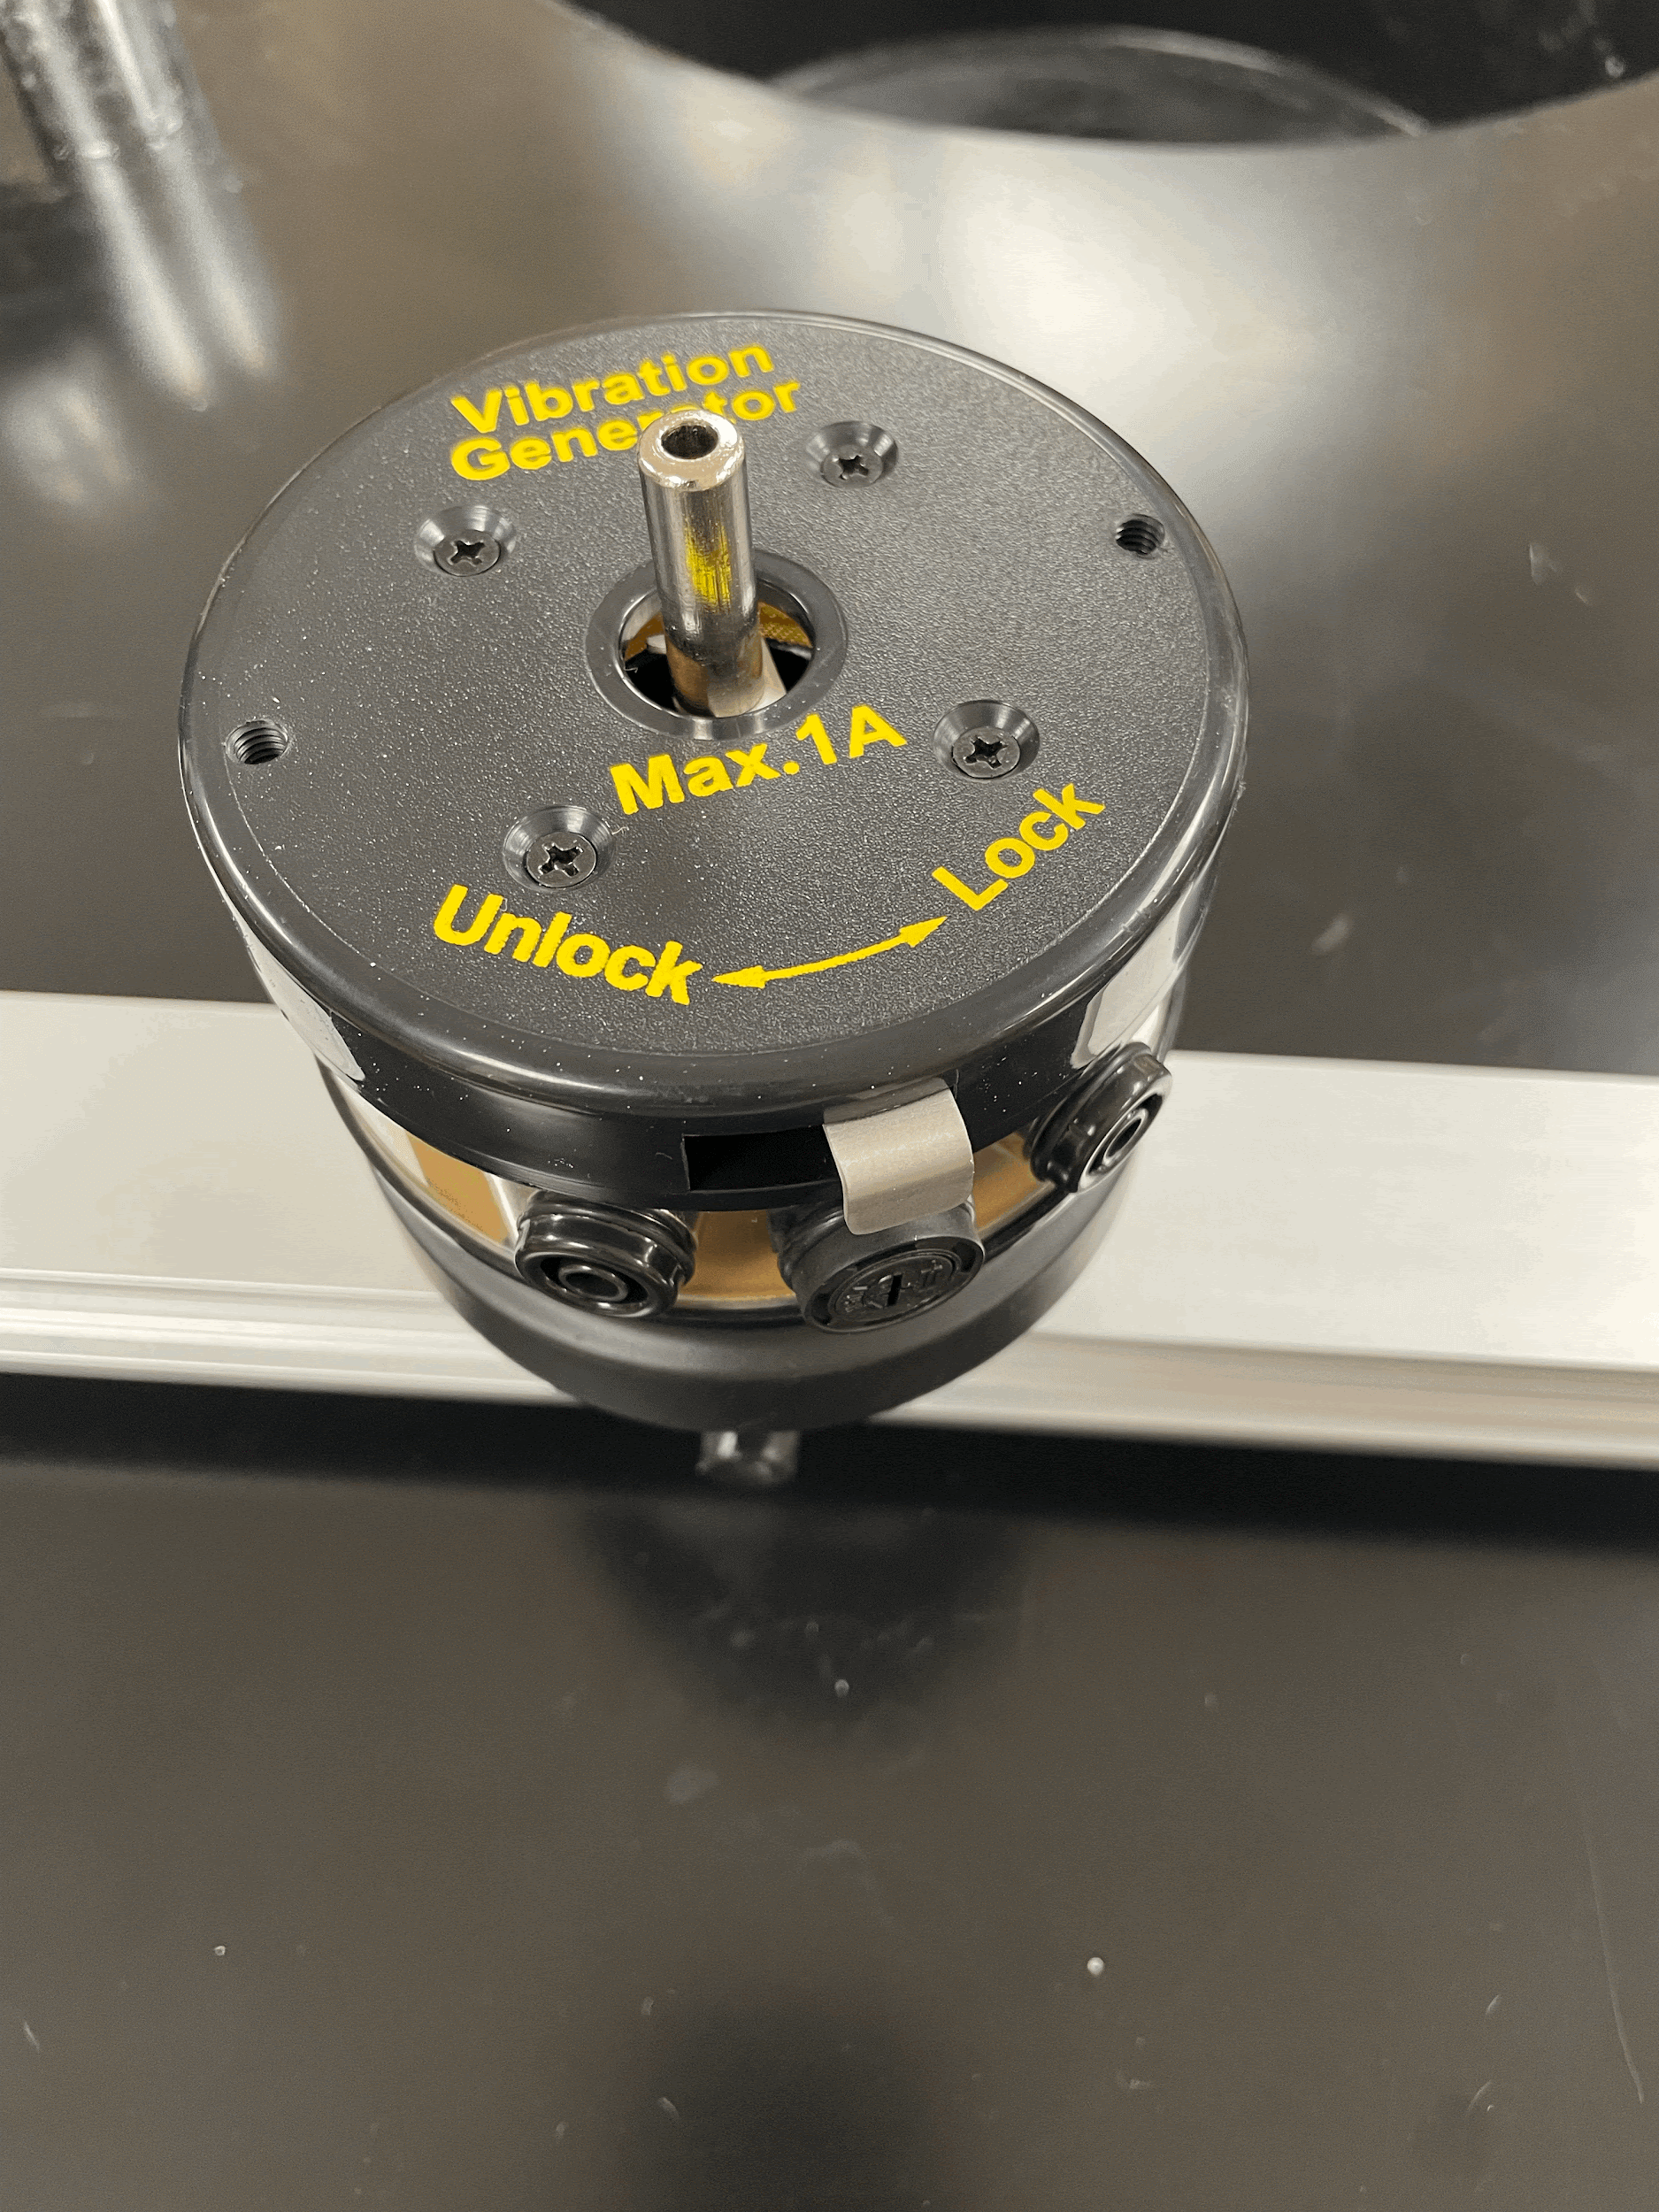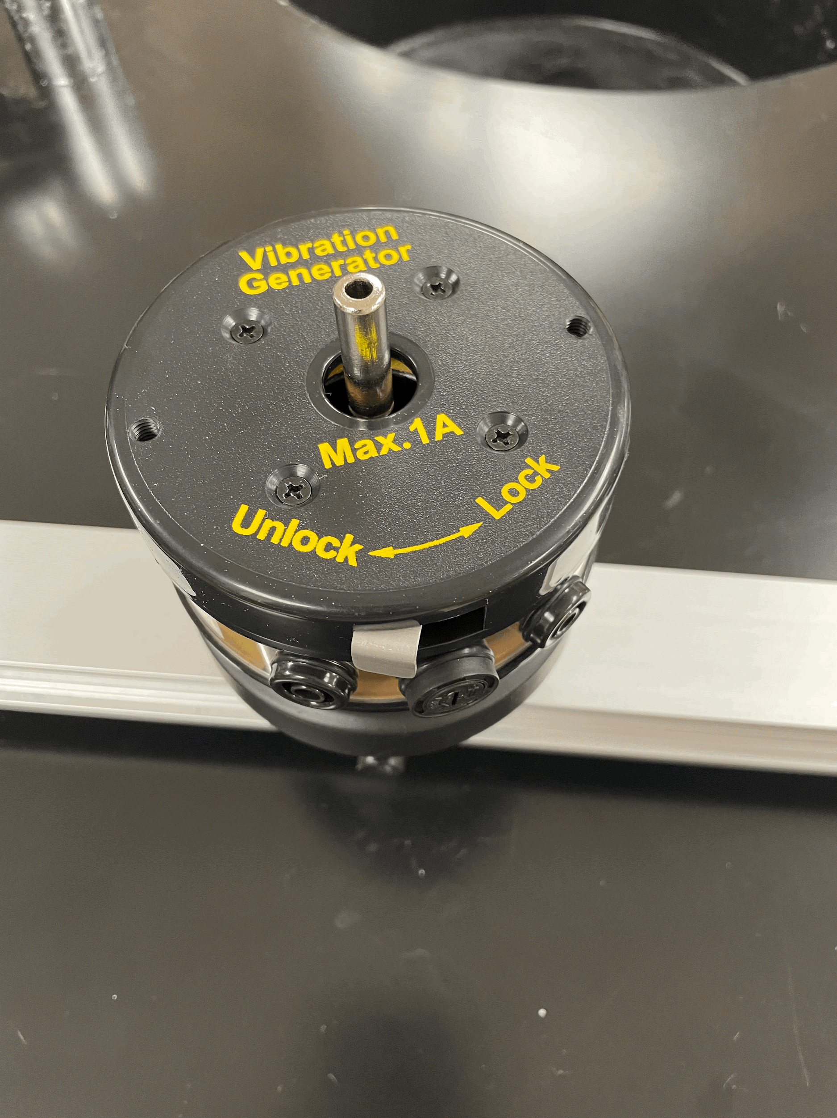

Figure 1: The vibration generator shown in the lock (a) and unlock (b) positions

Ensuring that the signal generator is off by checking the switch on the back, connect the red and black electrical cords to the vibration generator. Note: it DOES NOT matter which color cord goes where (AC current).

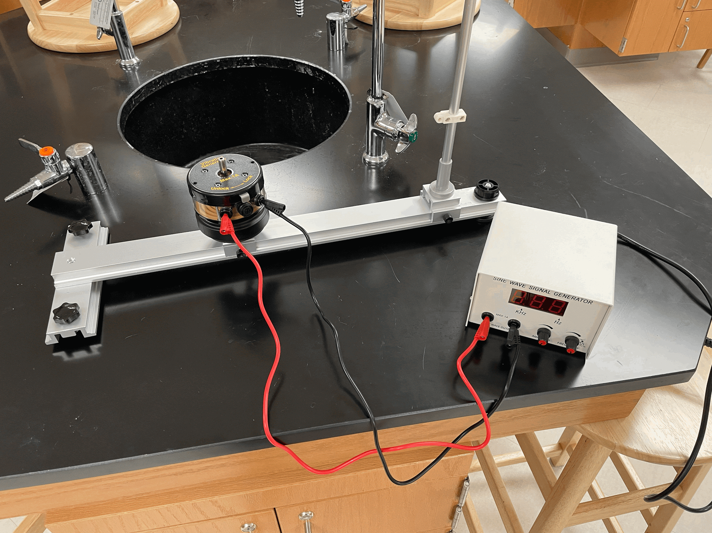

Figure 2: The signal generator connected to the vibration generator.

**EVERY TIME you are about to turn the signal generator on, make sure of these two things first:**

1. **The vibration generator is in the “unlocked” position**
2. **The “AMPLIFIER” knob (left knob) is turned all the way down (fully counterclockwise).**

Throughout this experiment you will be connecting different components to the vibration generator shaft and sweeping different frequencies and amplitudes. The “FREQUENCY” knob adjusts the output frequency. It will automatically default to 30 Hz when it is turned on. Pressing the knob will switch from “Hz” range to “kHz” range, as indicated by the lights on the screen. As you are sweeping frequencies, you may need to increase and decrease the amplitude to get the correct observations. Sometimes you will be able to hear when a frequency is of interest, and adjustment of the “AMPLIFIER” knob will allow you to observe the behavior at that frequency. Don’t forget to make sure that the knob is turned all the way down before turning the signal generator on the next time.

**Conducting the Experiment: Wire Hoop**

Take a piece of string and go around the wire hoop with the string. Mark the end of the string and measure the length. This will be the circumference of the ring.

Position the vibration generator near the center of the base rail, and tighten the thumbscrew to secure it in place. Insert the wire hoop into the vibration generator using the banana plug at the bottom (pictured below). Gently holding the generator shaft while inserting each component (as shown) can further help to reduce stress on the system.

Switch the vibration generator into “unlock” and turn on the signal generator. Turn the amplitude all the way up and start adjusting the frequency until you see multiple nodes. Using a slow motion camera, capture the generation of the waves from the wire hoop in front of the graphical display. Try to find frequencies associated with 3, 4, and 5 nodes. Do not surpass the frequency of 120 Hz. Record the frequency data and the videos to submit with your report.

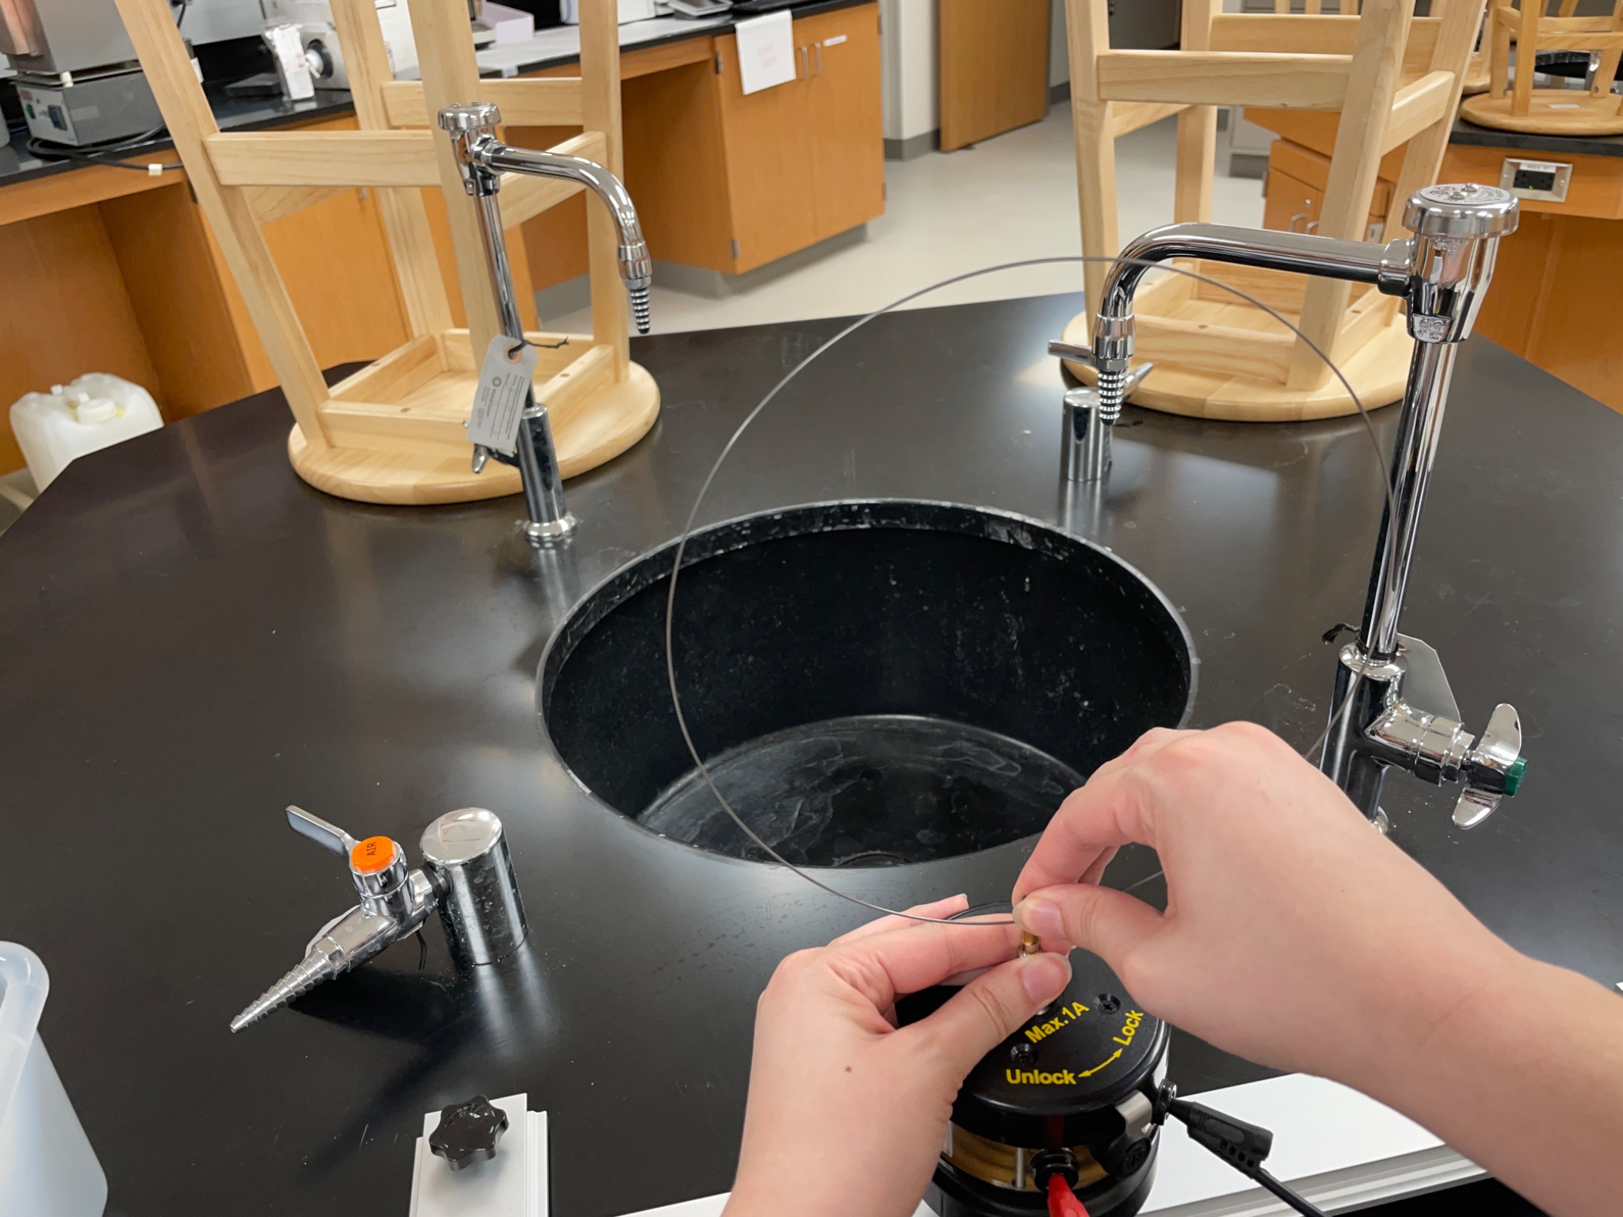

Figure 3: Connecting the wire hoop to the signal generator.

**Conducting the Experiment: Helical Spring**

Position the vibration generator directly next to the vertical support rod by loosening and tightening the thumb screw. Ensuring that the vibration generator is in the “locked” position and gently holding the generator shaft, insert the helical spring into the vibration generator using the banana plug at the bottom (pictured below). Take the other end of the spring and insert it through the hole at the top of the vertical support rod. The height of the rod can be changed by lifting the grey lever to unlock it and moving the top of the support rod up or down. Some of these components are plastic so be gentle when changing the height.

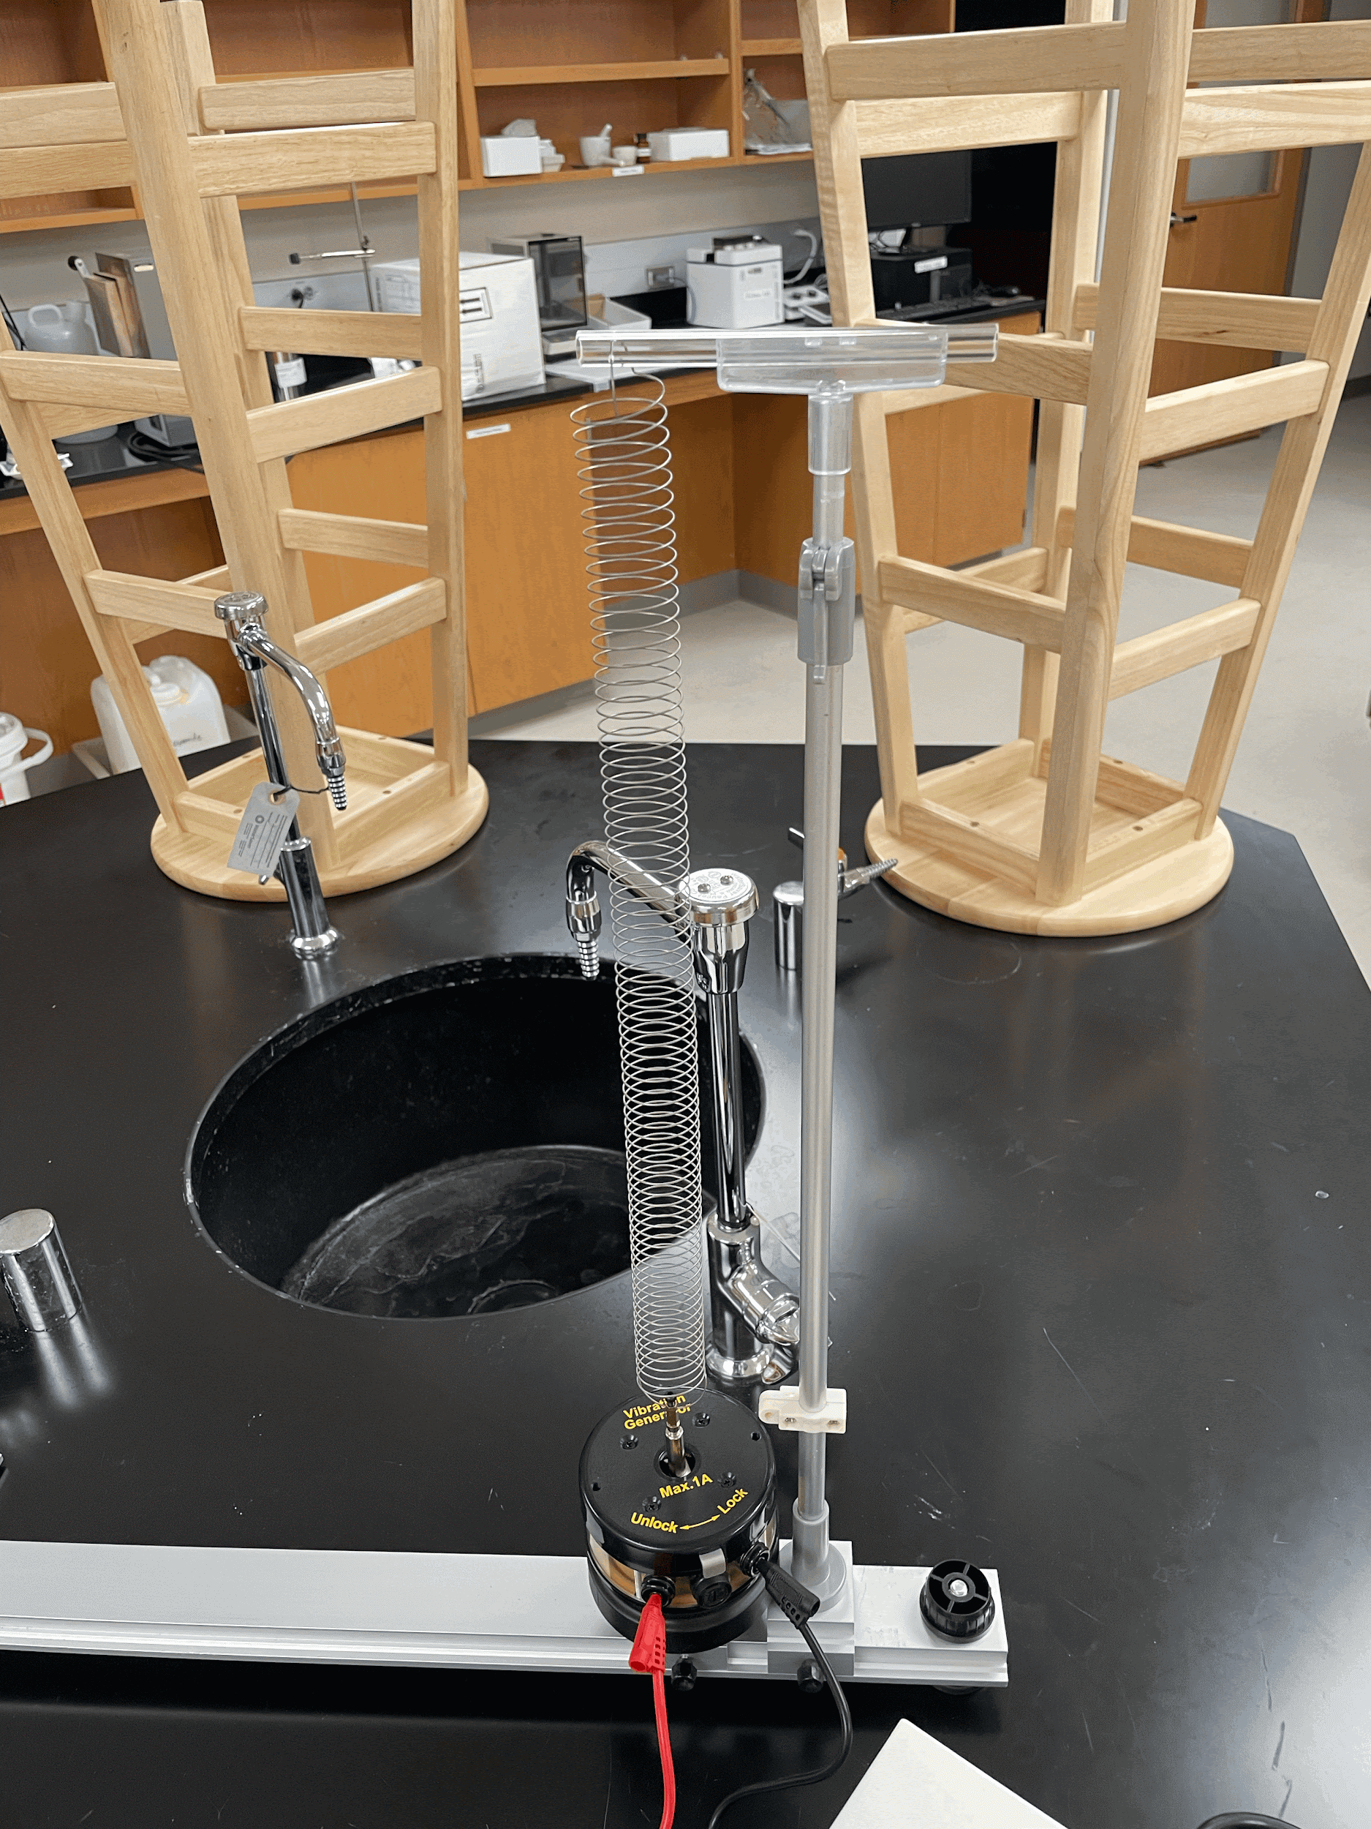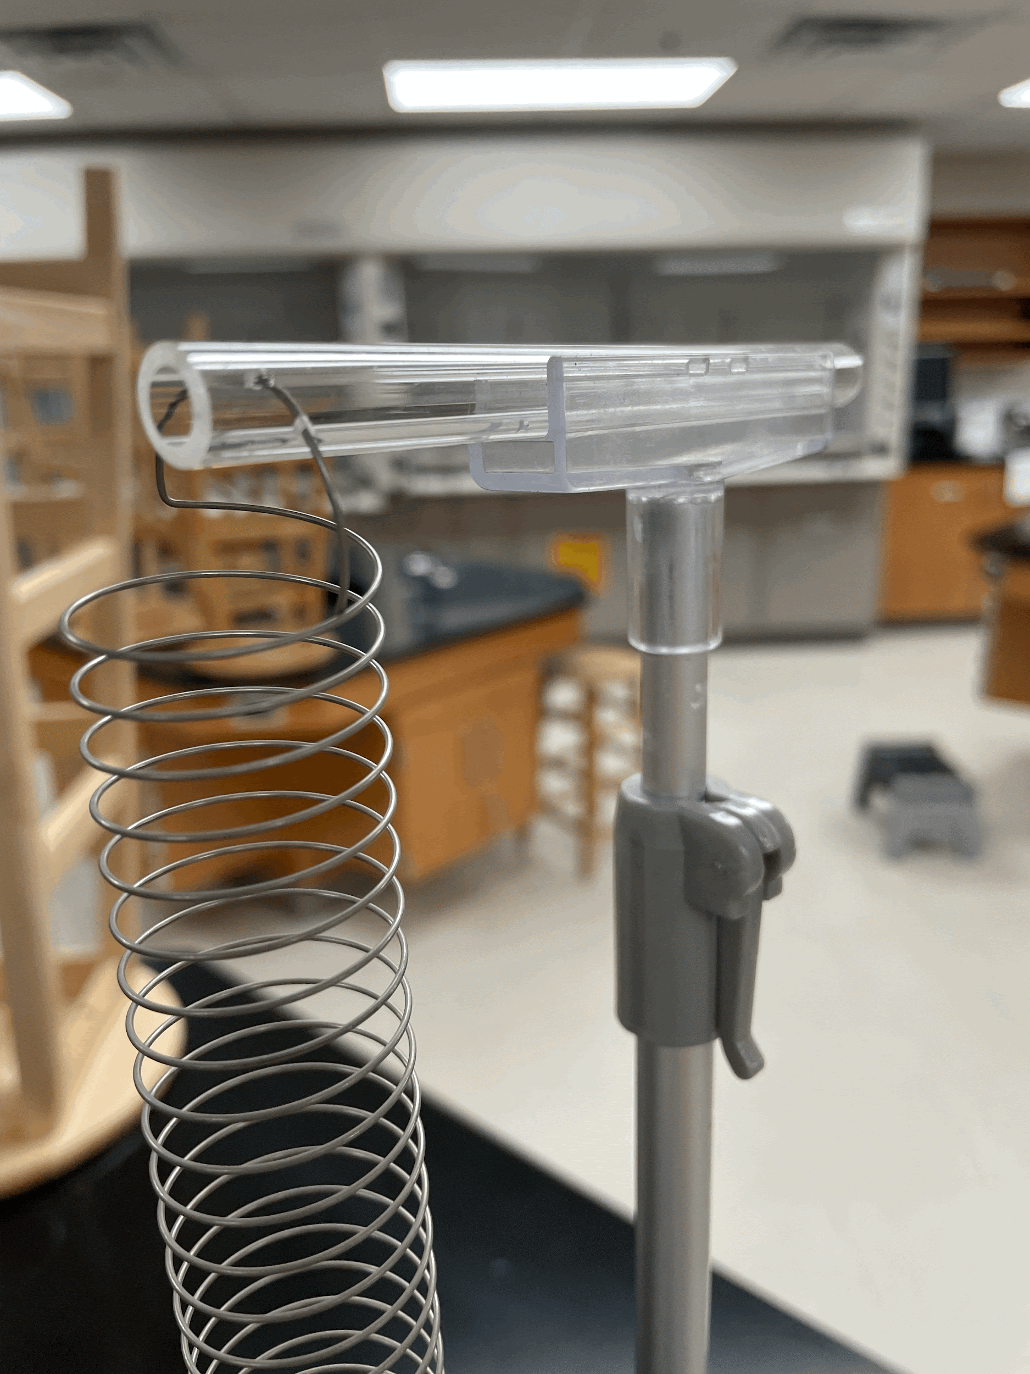

Figure 4: The helical spring connected to the signal generator and the support rod.

Measure the height of the support rod. Find a frequency where you can clearly see at least two nodes and find the distance between the nodes using a ruler. Find two more frequencies and record the distance between the nodes. Change the height. Record the new height and use the same three frequencies where you can clearly distinguish the nodes from before. Find the distance between the nodes at the new height.

**7. Calculations and Analysis**

**Part I Optics**

1. Calculate the refractive index and speed of light in Jello. Show your calculations.
2. Compare calculated values of the refractive index and speed of light through Jello with known values of water and glass.
3. Examine the relationship between the angle of incidence and refraction, plotting a graph of sin(*θi*) vs (*θr*) to verify Snell’s Law.

**Part II Waves**

1. Make a table showing the frequencies you recorded, how many nodes were found at each, and the wave speed for the wire hoop. Show how you calculated the wave speed.
2. Plot the number of nodes as a function of frequency.
3. Calculate the theoretical wavelength for the harmonic modes you observed. Compare these values with the experimentally measured wavelengths. Calculate the percent error. Show your calculations and put this data into a table.
4. Describe the relationship between node density (number of nodes per unit length) and frequency. Relate this observation to the energy quantization in quantum systems.
5. Make a table showing the frequencies, distance, wavelength, and speed for the helical spring for both the short and the tall rod. Show how you calculate the wavelength and wave speed.
6. Plot a graph of frequency vs wavelength. Determine the slope of the graph and explain its physical meaning in the context of wave mechanics. How does the slope relate to the wave speed?
7. Discuss how increasing the tension affects the wave speed and relate this observation to the wave-particle duality in quantum mechanics, where energy changes influence wave behavior.

**11. References**

1. *Educator Guide: Dropping In With Gravitational Waves*. NASA/JPL Edu. https://www.jpl.nasa.gov/edu/teach/activity/dropping-in-with-gravitational-waves/.